**ROUTE OPTIMIZATION FOR PREVENTION OF STREET HARRASSMENT IN MEDELLIN**

|  |  |  |  |
| --- | --- | --- | --- |
| Thomas Martinod  Universidad Eafit  Colombia  tmartinods@eafit.edu.co | Emanuel Serna  Universidad Eafit  Country  esernar1@eafit.edu.co | Andrea Serna Universidad Eafit Colombia asernac1@eafit.edu.co | Mauricio Toro  Universidad Eafit  Colombia  mtorobe@eafit.edu.co |

# **ABSTRACT**

# In this publication, street sexual harassment is identified as a degrading social problem that affects women around the world, who do not have access to real-time media to prevent it. After analyzing the rates of harassment and the localities that provide greater vulnerability in the case of the city of Medellin, different data structures are analyzed to know which one of them allows optimizing an algorithm that defines an arbitrary route over the city, considering the variables, distance $d$ and harassment index $R$.

# What is the algorithm you have proposed to solve the problem? What quantitative results have you obtained? What are the conclusions of this work? The abstract should be **at most 200 words**. (*In this semester, you should summarize here the execution times, and the results obtained with the three paths*).

## **KEY WORDS**

|  |
| --- |
| Street sexual harassment, shortest route, data structures. |

# **1. INTRODUCTION**

# Gender-based Street harassment occurs when a person is subject to unconsent sexual comments, gestures, and actions by any person in a public space. These types of actions are identified because they are directed at the victim due to their gender or sex.

# Actions which classify as street harassment include *catcalling*, sexist slurs and names, public sexual demands, masturbation, public flashing, and rape [1]. Street harassment is an issue all over the world, with a disproportionately greater effect on women. Although it’s a problem described as transnational, developing countries, which often have weak infrastructure, poor lighting conditions in public places and unsafe transport systems, often have worse cases of street sexual harassment.

# For instance, a study conducted by YouGov found that Bogota, Mexico City and Lima were among the top five worst cities in terms of verbal harassment [1]. Evidently, street harassment is an issue affecting safety perception in cities, on top of contributing to destructive feelings in victims.

# In Medellín specifically, 34.4% of underaged girls affirm that they are victims of street harassment, even several times a day, while 60% of women feel Medellin is not a safe city due to its persistent patriarchal culture [2]. Thus, the constant threat of harassment when walking around a city, including Medellin, leads to fear, and can even stop people from walking or using the city’s transportation network.

**1.2. Identification of the Problem**

As seen by the statistics exhibited above, street sexual harassment is a deep problematic affecting safety in most cities, including Medellin. However, woman all around the world find themselves defenseless, they do not have access to data that can help them avoid areas of the city where sexual harassment incidents are likely to occur.

Even worse, citizens and tourists usually rely on navigation platforms, such as Waze or Google Maps to obtain routes for traveling around the city. These types of applications calculate routes based solely on distance, which not only fails to inform users of unsafe areas but can also potentially lead people to take risker routes just because they are shorter. Thus, there’s a great need to develop an algorithm that calculates routes within the city based on both distance and safety.

In the case of sexual harassment, this means developing a shortest path algorithm that provides routes that are short and have a low risk of sexual harassment. Through the implementation of this algorithm, security perception in the city would improve greatly, more people, especially women, would be confident about walking and taking public transportation, and cases of street harassment hopefully may decrease significantly.

**1.2. Solution**

Explain, briefly, your solution to the problem *(In this semester, the solution is a pedestrian algorithm to reduce both the distance and the risk of harassment. Which algorithms did you choose? Why?)*

**1.3. Structure of the article**

Next, in Section 2, we present work related to the problem. Then, in Section 3, we present the datasets and methods used in this research. In Section 4, we present the algorithm design. Then, in Section 5, we present the results. Finally, in Section 6, we discuss the results and propose some directions for future work.

**2. RELATED WORK**

## Below, we explain four articles related to finding ways to prevent street sexual harassment and crime in general that may provide a great overview of this issue is being treated around the globe by the means of software development.

**2.****1. SafeStreet: Empowering women against street harassment using a privacy-aware location-based application**

## Scientists from the Bangladesh University of Engineering Technology and Dhaka University proposed a crowd-powered privacy-aware location based mobile application called *“SafeStreet”*, in order to reduce and prevent the sexual harassment against women in public places [3].

## This app allows women to privately document and share their own experiences, and, on the other hand, find the best path to a destination that has the least harassment hazard.

## *SafeStreet* works mainly with two important aspects, time, and place. Some research and studies made them conclude that sexual harassments are spatial-temporal in nature, which means they occur more frequently at a certain place or at a particular time.

## According to this fact, *SafeStreet* app has four major features: visualizing harassments, capturing harassments, reporting harassments, and searching safe routes. The first three of them allow users to capture personal experiences either privately or by sharing them with the rest of users and see other harassment reports of surrounding regions in a map.

## Finally, for safe routed searching, the app uses a route search algorithm that finds out the shortest path from the starting location of the user to her destination, considering the harassment records (location and time) to be the weight. With all that information, their server process runs the route search algorithm and returns necessary paths to the mobile user.

**2.2. Secure Routing with Crowdsourcing**

A group of investigators in Mexico City were concerned with security issues that arise in big cities and urban centers, especially in developing countries where crime is more widespread. Popular mobile systems compute paths based entirely on distance, and don't consider safety hazards that may arise along a recommended route.

Thus, the researchers, developed an approach that integrates crowd-reported crime data with official government data to obtain safer routes in Mexico City for both locals and tourists. The academic paper states that a preliminary experiment was implemented with 75% of effectiveness [4].

The approach proposed by the researchers consists of collecting Tweets that are related to crime and integrating them with crime data from official governmental institutions through an automatic system that considers descriptions and attributes in the data. After this, the *Bayes algorithm* [1] is used to classify data that couldn't be integrated automatically. Most importantly, this algorithm is used to assign probabilistic crime rates to specific parts of the city.

After collecting, sorting, and classifying the data, a mobile application was developed to display the safest route between two given locations. The safe route is obtained though the Dijkstra algorithm, in which the weight of the nodes is derived from the average number of crimes in the given location. Thus, the algorithm outputs a route that avoids places with higher crime rates.

**2.3. A Navigation System for Safe Routing**

This novel system was created by scientists from the Indraprastha Institute of Information Technology Delhi, Indian Institute of Technology Ropar and Indira Gandhi Delhi Technical University for Women and was presented in 2021 during the 22nd IEEE International Conference on Mobile Data Management (MDM) [5].

This system consists of an algorithm that recommends routes to move from one place to another by balancing the requirements of increasing the safety and constraining the total length of the path. Their target and main focus were the city of Delhi in India. They compute street level safety by collecting information from news, social media and government websites and then applying processing techniques using tools from machine learning, natural language processing, and geocoding to transform the data into a usable form of safe routing.

In order to make this system as effective as possible, they use multiple data sources including crime data from news websites, crime statistics data from the NCRB website, public transport data, traffic data, image data, road quality data and police stations coordinates.

## After processing all the data extracted previously and generating safety scores, a Multiple Segment Replacement algorithm does its job, firstly, finding a seed path from $s$ (the origin), to $d$ (the destination), then, estimating score gain for all segments of the seed path, then, selecting a set of segments for replacement, and finally, replacing the chosen segments in the seed path while checking the budget constraint. With all of these, the user receives the best possible route considering both safety and quickness.

## **2.4. *SafePaths***

Finally, Galbrun, Pelechrinis and Terzi [6] were the first to define safe routes with the use of criminal data. Specifically, concerned with growing insecurity in cities, and aiming to takeadvantage of publicly available

datasets, the investigators sought to improve the quality of life of those traveling around cities by developing an algorithm that uses criminal data to yield navigation options based on both distance and

safety. The preliminary experiment was done using data from Chicago and Philadelphia, which they used to create a city risk model that included the probability of crime on any given road segment.

Overall, their central objective was to find a short and low-risk route between two given locations. However, since these two variables cannot be computed together as a single problem, the investigators developed a solution based on a bi-objective shortest path problem that outputs a set of paths that have varying degrees of safety and distance [6].

Despite their success, this SafePaths problem is based on crime in general, and fails to address specific types of crime, such as street harrasment, along a certain path. The investigators working on the SafePaths problem used a deterministic algorithm to determine the best route, which is done by computing all possible routes between two given locations.

Overall, given a fixed pair of origin and destination locations, the algorithm computes two important paths: the safest path and the shortest path. When these two initial paths differ, as it is often the case, a recursive algorithm is then used to consider, in each iteration, an intermediate non-dominated path between the original intervals. This process is repeated until the difference between the shortest and the safest path is minimal [6].

## **3. MATERIALS AND METHODS**

In this section, we explain how the data were collected and processed, and then different alternative path algorithms that reduce both the distance and the risk of sexual street harassment.

## **3.1. Data collection and processing**

The map of Medellín was obtained from *Open Street Maps* (OSM)[2]  and downloaded using the Python API[3] OSMnx. The map includes (1) the length of each segment, in meters; (2) the indication of whether the segment is one-way or not, and (3) the known binary representations of the geometries obtained from the metadata provided by OSM.

For this project, a linear combination (LC) was calculated that captures the maximum variance between (i) the fraction of households that feel insecure and (ii) the fraction of households with incomes below one minimum wage. These data were obtained from the 2017 Medellín quality of life survey. The CL was normalized, using the maximum and minimum, to obtain values between 0 and 1. The CL was obtained using principal components analysis. The risk of harassment is defined as one minus the normalized CL. Figure 1 presents the calculated risk of bullying. The map is available on GitHub[4] .

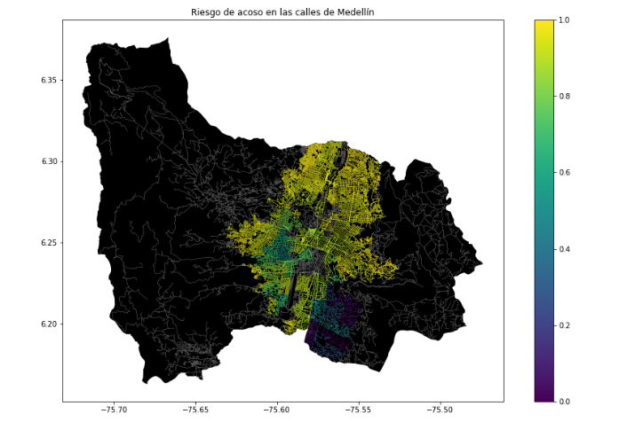

***Figure 1.*** *Risk of sexual harassment calculated as a linear combination of the fraction of households that feel unsafe and the fraction of households with income below one minimum wage, obtained from the 2017 Medellín Quality of Life Survey*.

## **3.2. Algorithmic alternatives that reduce the risk of sexual street harassment and distance**

## In the following, we present different algorithms used for a path that reduces both street sexual harassment and distance.

***3.2.1. Dijkstra’s algorithm***

Given a graph and a source vertex in the graph Dijkstra's shortest path algorithm is used to find the shortest paths from the source to all vertices in the given graph, mainly regarding distance. As a result, when using Dijkstra's to create risk-free paths for a short distance, the output will most likely be the one with the fewest hops and longer paths will be overlooked by this algorithm [7].

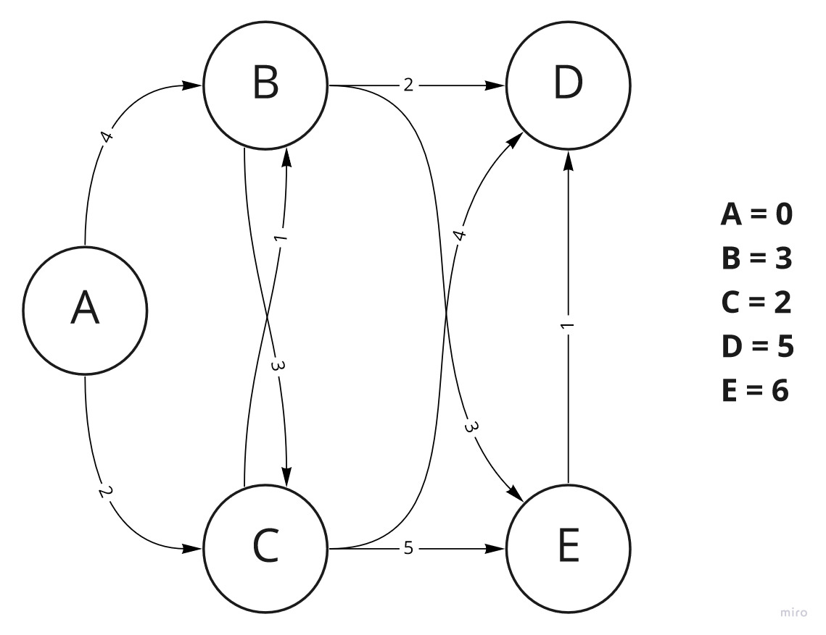

***Figure 2.*** *Graph of Dijkstra’s algorithm*

Dijkstra’s algorithm starts by labeling each node with the known distance from the source. Before any calculations are made, the source node is assigned a value of 0, and all the other nodes are assigned a value of $∞$. The values of the nodes distinct from the source are updated as the algorithm is executed, and the value will always represent the shortest distance found until that point. As the first step, the algorithm “travels” through all the edges connected to the source node and updates the value of the distance taken to get to each of the “secondary” nodes. After this, the algorithm chooses the secondary node with the shortest distance and calculates the new distances through the edges that depart from the choose secondary node. If a new distance is shorter than one found in the previous step, the distance assigned to that node is updated. In addition, the algorithm keeps track of the path followed to obtain the assigned shortest distance. Overall, Dijkstra’s algorithm follows 3 main steps: updates node distances, keeps track of paths followed, and chooses the next vertex. Once all vertices on the graph had been visited, the value assigned to each node, with its corresponding route, is the shortest distance and path from the source node [7].

***3.2.2. The Bellman-Ford algorithm***

The Bellman–Ford algorithm is an algorithm that computes shortest paths from a single source vertex to all of the other vertices in a weighted digraph. It is slower than Dijkstra's algorithm for the same problem, but more versatile, as it is capable of handling graphs in which some of the edge weights are negative numbers.

Like Dijkstra's algorithm, Bellman–Ford proceeds by relaxation, in which approximations to the correct distance are replaced by better ones until they eventually reach the solution. In both algorithms, the approximate distance to each vertex is always an overestimate of the true distance and is replaced by the minimum of its old value and the length of a newly found path. However, Dijkstra's algorithm uses a priority queue to greedily select the closest vertex that has not yet been processed and performs this relaxation process on all of its outgoing edges; by contrast, the Bellman–Ford algorithm simply relaxes all the edges and does this $\left|V\right|-1$ times, where $\left|V\right|$ is the number of vertices in the graph. In each of these repetitions, the number of vertices with correctly calculated distances grows, from which it follows that eventually all vertices will have their correct distances [8].



***Figure 3.*** *Visual graph of Bellman algorithm*

***3.2.3. Bresenham's line algorithm***

Bresenham’s line algorithm is a line drawing algorithm that determines the points of an *n*-dimensional raster that should be selected in order to form a close approximation to a straight line between two points. The general concept of this algorithm is: given a starting endpoint of a line segment, the next grid point it traverses to get to the other endpoint is determined by evaluating where the line segment crosses relative to the midpoint (above or below) of the two possible grid points choices. Basically, this algorithm considers some variables defined previously by the programmer and, regarding these parameters, decides between two different points of destination [9].

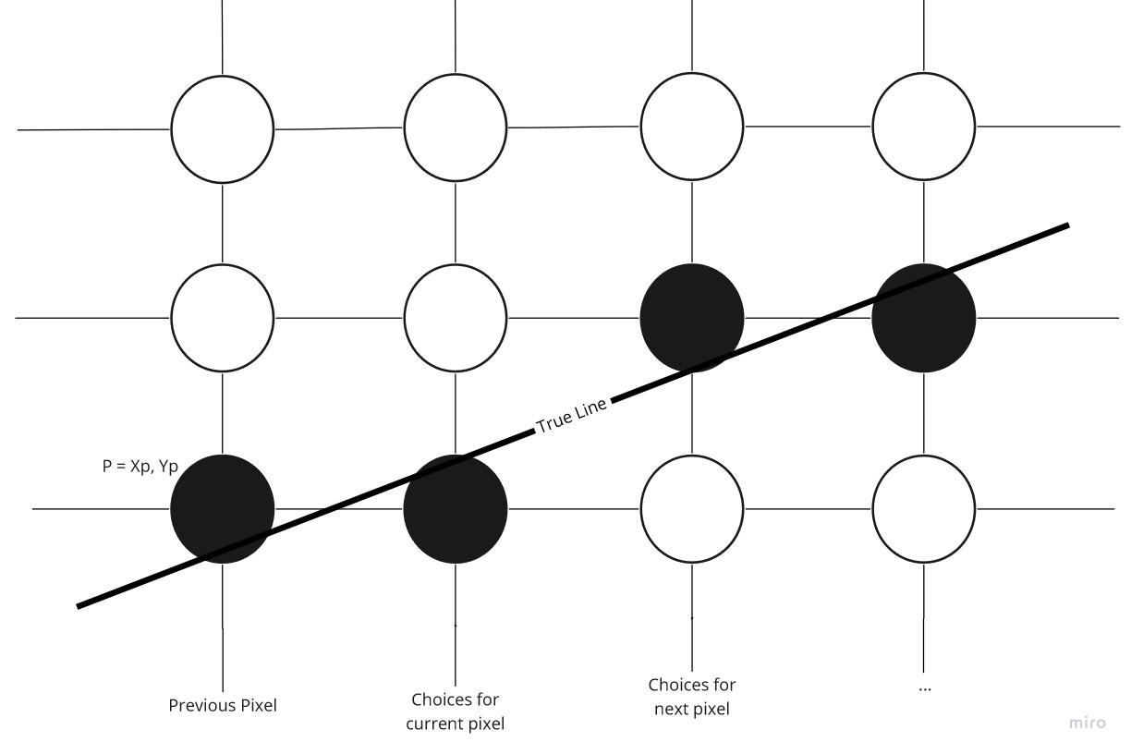

***Figure 4.*** *Trajectory of Bresenham’s line algorithm*

***3.2.4. Breadth-first search algorithm (BFS)***

The breadth-first search algorithm is used for searching tree data structures until a node with a certain condition is found. The algorithm starts at the root node and explores each level of the tree completely before moving on to the next level. This differs from the depth-first search algorithm, which explores a tree branch until its last level before backtracking and exploring other branches.

Among many other things, breadth-first search is used for finding the shortest path from a source vertex to all the other nodes on the graph. Unlike other algorithms, like Dijkstra’s and Floyd-Warshall, breadth-first search is used on graphs that are unweighted. This means that edges between nodes are not assigned a specific length. Instead, the distance from a certain node to the source node is determined by how many levels beneath the source node it is found, with each level being assigned a value of one [10].

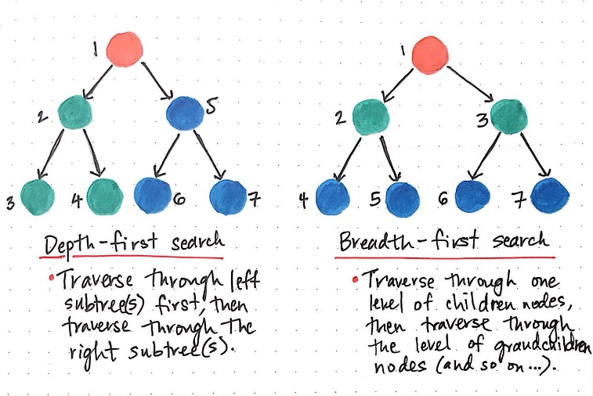

***Figure 5.*** *Differences between DFS and BFS algorithms.*

# **REFERENCES**

[1] Stop Street Harassment, 2022. What Is Street Harassment? | Stop Street Harassment. [online] Available at: [https://stopstreetharassment.org/about/what-is streetharassment/](https://stopstreetharassment.org/about/what-is%20streetharassment/)

[2] Ruta N Medellín, 2022. Reducir el acoso callejero: el reto de la Secretaría de Mujeres - Ruta N. [en línea] Disponible en: https://www.rutanmedellin.org/es/programasvigentes/2-sin categorizar/592-reto-de-mujeres

[3] Mohammed Eunus Ali, Shabnam Basera Rishta, Lazima Ansari, Tanzima Hashem, and Ahamad Imtiaz Khan. 2015. SafeStreet: empowering women against street harassment using a privacy-aware location based application. New York, NY, USA, Article 24, 1–4. <https://doi.org/10.1145/2737856.2737870>

[4] Mata, F., Torres-Ruiz, M., Guzmán, G., Quintero, R., Zagal-Flores, R., Moreno-Ibarra, M. and Loza, E., 2016. A Mobile Information System Based on Crowd-Sensed and Official Crime Data for Finding Safe Routes: A Case Study of Mexico City. [online] Mobile Information Systems Available at: <https://www.hindawi.com/journals/misy/2016/8068209/>

[5] R. Kaur et al., "A Navigation System for Safe Routing," 2021 22nd IEEE International Conference on Mobile Data Management (MDM), 2021, pp. 240-243, doi: 10.1109/MDM52706.2021.00047.

[6] Galbrun, E., Pelechrinis, K. and Terzi, E., 2015. Urban navigation beyond shortest route: The case of safe paths. [online] Science Direct. Available at: https://www.sciencedirect.com/science/article/pii/S0306437915001854.

[7] Sharon Levy, Wenhan Xiong, Elizabeth Belding, and William Yang Wang. 2020. SafeRoute: Learning to Navigate Streets Safely in an Urban Environment. ACM Trans. Intell. Syst. Technol. 11, 6, Article 66 (September 2020), 17 pages. https://doi.org/10.1145/3402818

[8] Bellman–Ford algorithm, Wikipedia, 20-May-2022. [Online]. Available: [https://en.wikipedia.org/wiki/Bellman%E2%80%9](https://en.wikipedia.org/wiki/Bellman%E2%80%259) Ford_algorithm. [Accessed: 16-Aug-2022].

[9] Ma, D., 2019. Preventing Sexual Harassment by Finding the Safest Route Using Grid Coverage Techniques. [online] Medium. Available at: <https://medium.com/omdena/preventing-sexual-harassment-by-finding-the-safest-route-using-grid-coverage-techniques-77c920b3882> [Accessed 16 August 2022].

[10] Wikipedia, 2022. Breadth-first search. [online] Wikipedia. Available at: https://en.wikipedia.org/wiki/Breadth-first_search

1. A probabilistic algorithm based on Bayesian probability
2. <https://www.openstreetmap.org/>
3. https://osmnx.readthedocs.io/
4. https://github.com/mauriciotoro/ST0245Eafit/tree/master/proyecto/Datasets